MARY, GATE OF HEAVEN PARISH
St. Mary Church & St. Robert Bellarmine Church
St. Mary (860) 623-2524 * FAX (860) 623-5684
Email: office@marygateofheaven.org

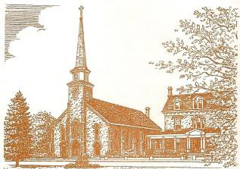
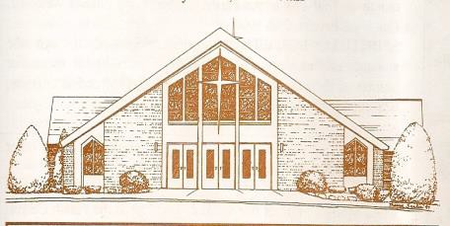

Information for Baptismal Register

Child’s Name _______________________________________________________________ Date of Birth______________
first middle last

Home Address ___________________________________________________________________________________________
Number street city/town state zip code

Phone Number ______________________________ Place of Birth _________________________________________

Email __________________________________________________
Father’s Name ___________________________________________________ Father’s Religion ___________________
Mother’s Maiden Name ___________________________________________ Mother’s Religion __________________
first name (maiden) name

Church where parents were married: _________________________________________________________________________
name
Location of Church: __________________________________________________________________________________
city/town state

Name of Godfather _________________________________________ Name of Godmother _______________________
Is the Godfather a Catholic? YES _____ NO _____ Is the Godmother a Catholic? YES ____ NO _____
What parish does the Godfather attend? ________________________________________ Sponsor Form __
YES/NO
What parish does the Godmother attend? _______________________________________ Sponsor Form ___ YES/NO
Will a Proxy be represent for either Godparent? YES ____ NO ____

If yes, please give the name of the Proxy __________________________________________________________
Was the child privately baptized? YES ____ NO _____
Was the child adopted? YES ____ NO _____
Do you have any special requests? _________________________________________________________
Are you a registered member of Mary, Gate of Heaven Parish (St. Mary/St. Robert Bellarmine Churches)? __
Date of Pre-Baptismal Instruction ____/_____/______
Date and time of Baptism

Rev 5/2024

